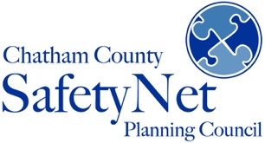

Safety & Resilience Programs
Chatham County Safety Net Planning Council develops and implements programs to promote safety and resilience in Chatham County. The Safety and Resilience programs aim to meet our community’s needs for effective, accessible, and affordable resources and training in four main areas: (1) Suicide Prevention, (2) Emotional Wellbeing, (3) Trauma-Informed Practices, and (4) Health & Wellness.
We use a comprehensive public health approach to creating a suicide safer community by developing and implementing resiliency-building programs that address physical, emotional and mental wellbeing.
To ensure equity and access to the Safety & Resilience resources for a wide range of professionals and community members, we offer various training programs and workshops at no or low cost.
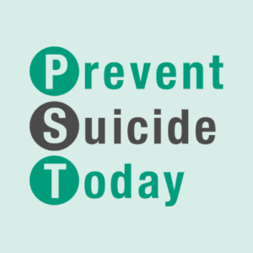
PREVENT SUICIDE TODAY (PST) is a community-based program working to prevent suicide by raising awareness about suicide and providing skills-based evidence-based suicide intervention and prevention training, to include:
- Applied Suicide Intervention Skills Training (ASIST) is an evidence-based 2-day interactive
workshop in suicide first aid. ASIST is offered monthly and at no cost to community residents.
      - SafeTALK is an evidence-based 4-hour alertness training that prepares anyone 15 or older, regardless of prior experience or training, to become a suicide-alert helper.
      - SuicideTALK / Q.P.R. (Question, Persuade, Refer) is an evidence-informed 60-minute training in suicide awareness.
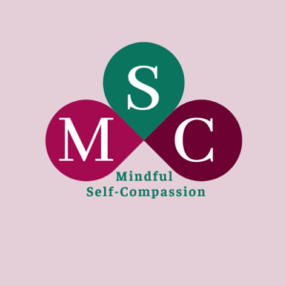
MINDFUL SELF-COMPASSION (MSC) is a community-wide evidenced-based program working to build resilience and enhance emotional wellbeing by providing training and resources to the public for learning and practicing mindfulness and self-compassion.

- MSC Essentials is an introductory session in mindfulness and self-compassion.
      - MSC Fundamental Concepts & Skill is a 1-2 day intensive in mindful self-compassion.
      - MSC 8-week Course is an evidence-based 8-week course designed to cultivate the skills of self-compassion and develop MSC teachers.
      - Self-Compassion for Caregivers is the evidence-based course designed to cultivate the skills of self-compassion for individuals in caregiving roles to address caregiver fatigue and burnout.

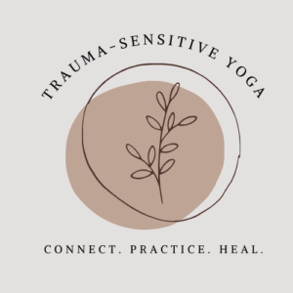
TRAUMA-SENSITIVE YOGA (TSY) program uses the evidence-based clinical adaptation of a yoga practice designed as a therapeutic intervention for individuals impacted by trauma, including complex trauma and post-traumatic stress disorder (PTSD).
      - TSY for Children & Youth uses mindful movement and activities to help children build the skills of self-awareness and emotional regulation.
      - TSY for Stress Management and Burnout is designed to help participants reduce stress and elicit the relaxation response physically, emotionally, and mentally through gentle movement, focused attention, and breath work.
      - Chair TSY uses modified yoga poses so they can be done while seated in a chair to make practices accessible to people who cannot stand, lack the mobility to move easily from standing to seated to supine positions, or do not have a yoga mat.
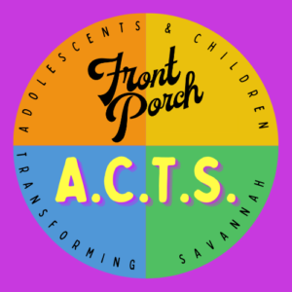
FRONT PORCH A.C.T.S.: Adolescents & Children Transforming Savannah program uses the evidence-based Trauma Drama curriculum – an immersive group intervention – designed to integrate the core components of complex trauma intervention with at-risk youth and adolescents.

- Front Porch A.C.T.S. Workshop is a 60-90-minute class that engages participants in cooperative play activities, improvisational techniques, and theatrical skits to promote opportunities for self-expression, cognitive flexibility, creative problem solving, conflict resolution, and enhanced sense of personal agency.
- Front Porch A.C.T.S. 7-12 Week Course is an evidence-based intervention designed for at-risk youth and young adults to build coping skills and resilience in the face of trauma using improvisation, theatre, and cooperative play activities.

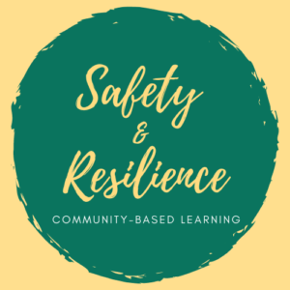
SAFETY & RESILIENCE evidence-informed workshops educate community members about trauma, Adverse Childhood Experiences (ACEs), and trauma-sensitive/trauma-informed practices to support development of trauma-responsive systems.
- The Community Resiliency Model (CRM)® is an evidence-informed training that helps create “trauma-informed” and “resiliency-informed” individuals and communities that share a common understanding of the impact of trauma and chronic stress on the nervous system and how resiliency can be restored or increased using this skills-based approach.
- Trauma-Sensitive Interactions (TSI) is an evidence-informed training in creating a trauma-sensitive environment. This workshop draws on work and research of the evidence-based course Trauma-Sensitive Mindfulness®, the Substance Abuse and Mental Health Services Administration (SAMHSA), and the National Center for Trauma-Informed Care (NCTIC).

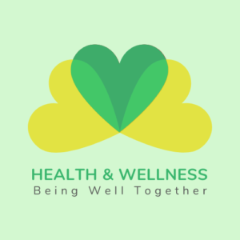
HEALTH & WELLNESS workshops build awareness of making choices toward a healthy and fulfilling life by educating participants about the importance of practicing a healthy lifestyle, exploring the physical, emotional and social dimensions of wellness, and offering tips for embracing one’s personal wellness.

